**ASSIGNMENTNo.9**

**Title : Matlab Solver for all Numerical Methods**

**1. Roots of Equation**

>> f =inline('x^2 + 10*x-3100')

f =

Inline function:

f(x) = x^2 + 10*x-3100

>> root = fzero(f,0)

root =

50.9017  
  
 **2. Numerical Integration**

>> f =inline('3*(0.4+0.004*T)')

f =

Inline function:

f(T) = 3*(0.4+0.004*T)

>> I =quad(f,25,125)

I =

210  
  
  
  
**3. SimultaneousEquation**

>>A=[243;361;132]

A=

2 4 3

3 6 1

1 3 2

>>B=[13;16;9]

B=

13

16

9

>>X=linsolve(A,B)

X=

1.0000

2.0000

1.0000  
  
**4. Curve Fitting**

**a) Straight line**

>> X=[19253036404550]

X=

19 25 30 36 40 45 50

>> Y=[76777980828385]

Y=

76 77 79 80 82 83 85

>> plot(X,Y)  
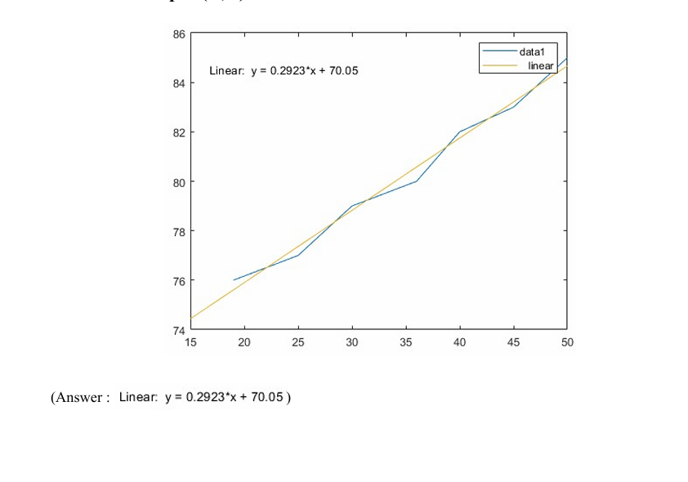

**5. Interpolation**

>> X=[-12 10 38]

X=-12 10 38

>> Y=[50.1 10 4.9]

Y=

50.1000 10.0000 4.9000

>> Xg=interp1(Y,X,16,"spline")

Xg =-15.6600  
  
  
6. OrdinaryDiff.Equation

>>f=inline('(x^2)/(y^2+1)')

f=

Inlinefunction:

f(x,y)=(x^2)/(y^2+1)

>>[XnYn]=ode23(f,[0,1],0)  
  
**Xn=**

0

0.0250

0.0500

0.0731

0.0962

0.1192

0.1423

0.1654

0.1918

0.2225

0.2581

0.2995

0.3474

0.4030

0.4677

0.5431

0.6315

0.7315

0.8315

0.9315

1.0000

**Yn=**

0

0.0000

0.0000

0.0001

0.0003

0.0006

0.0010

0.0015

0.0024

0.0037

0.0057

0.0090

0.0140

0.0218

0.0341

0.0533

0.0838

0.1298

0.1894

0.2634

0.3222